CSIS 3175

Mobile App Development Interim Report

By:

Gurpreet Gurpreet 300316454

Daisuke Kawabuchi 303317393

Scott Linden 300327715

Ismael Josia Moreno Moya 300323765

**Activities Description**

**Splash Activity** - When the app loads up there is a simple trackChip Logo on the screen for a few seconds before fading to the home page. Most likely in the next iteration there will be a log-in activity in between the splash activity and the main activity. 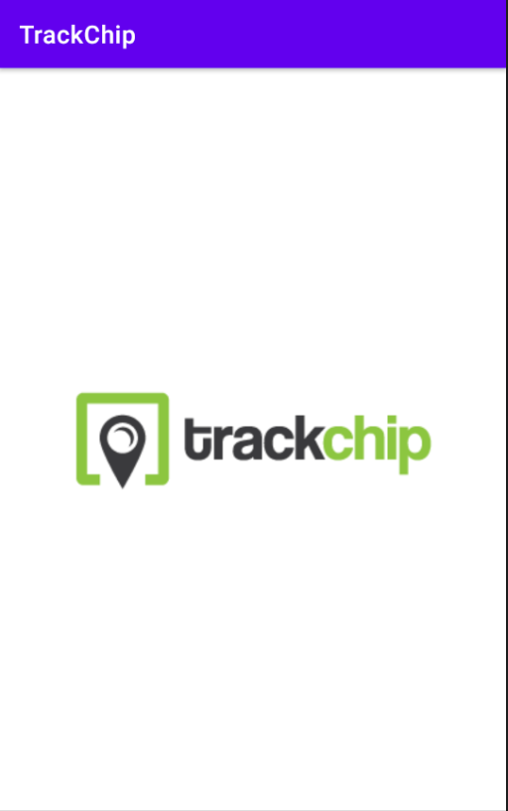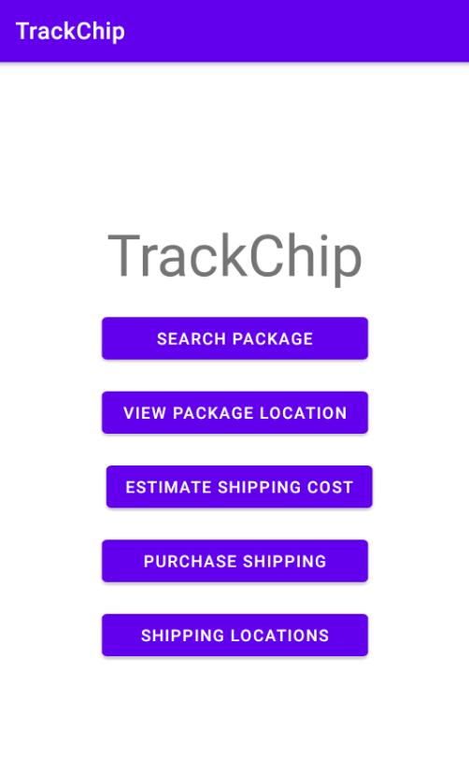

**Search packages** - On the main page there is an easy to access text entry field for users to enter tracking information to get current up to date information about a package. The tracking number should be at least 4 characters long, if the user enters a valid tracking number the tracking information will be displayed in a list. If the length is less than 4 characters a toast message will be displayed to enter a valid tracking number.

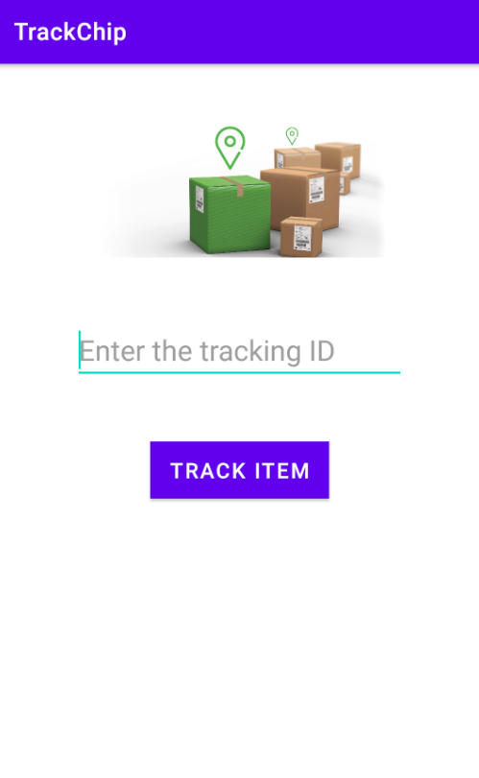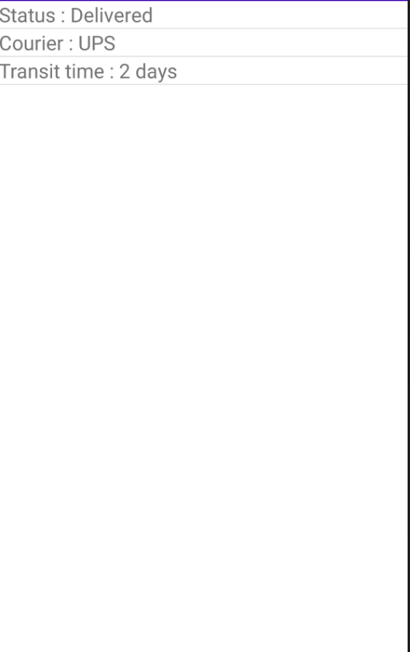

**View Package Location** - Users will be able to see up to date information about their package’s location. This page will be able to tell the user if the package is out for delivery, at a sort facility, or still needing to be picked up to ship out. This activity will show users the location of the package, along with the journey that the package takes. It will also show users the estimated date that the package will be delivered. Bullet points and lines show whether each activity(shipped, out for delivery, delivered etc.) is complete or ongoing.

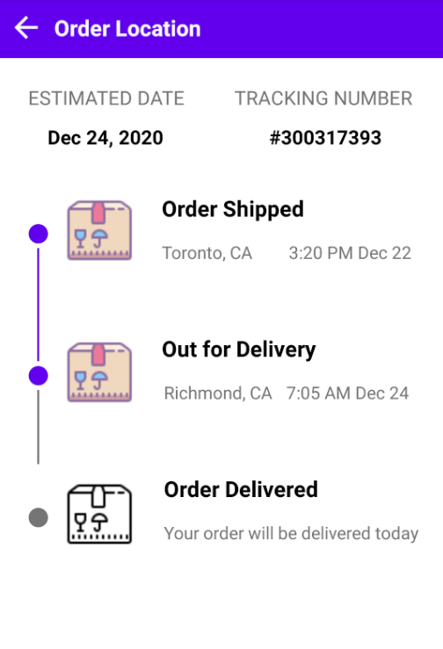

**Estimate Shipping** - Users will be able to enter in information about a package they want to ship. At the moment the estimated shipping activity asks the user for the package length, width, depth, and weight. A calculation is completed in the background to determine a shipping cost based around these factors. In future iterations we may include a button to go to the purchasing page, but for now this is purely an estimation page.

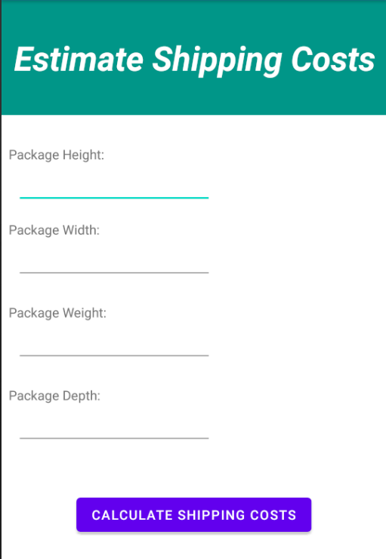

**Purchase Shipping** - On this activity user will be prompted for the package information, Destination location type such as a residence or a business, after, using a spinner asks for the packaging type, that can be a package prepared by the customer or the multiple packages offered by the company, if the package selected is a custom package prompts for its dimensions and weight, finally another spinner is used to select the type of shipping the user prefers being options: Express early, saver, expedited or standard types finally a button is used and will display the amount to pay and payment options later when purchase is completed will display the information of how to ship the package, payment and confirmation activities have not been implemented yet.

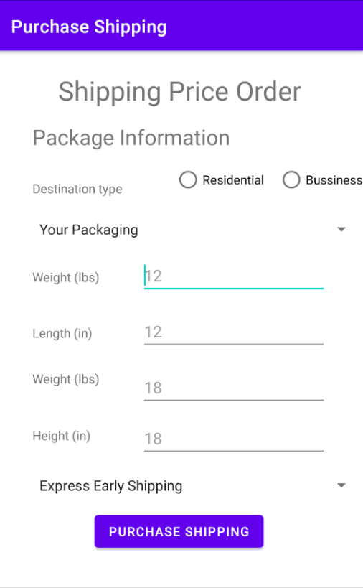

**Shipping Locations** This activity will incorporate a connection to the google maps api making a search for the nearest shipping offices locations and display a list with their directions, users will be able to click on any item of the list and will be redirected to google maps with the current location for the office.

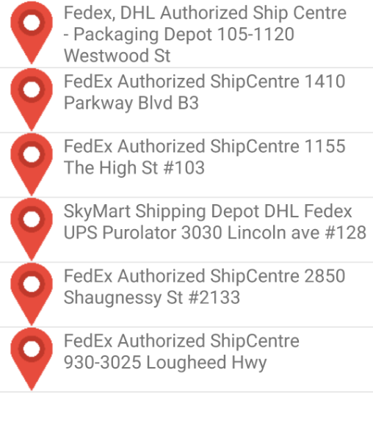

**Scheduled Tasks**

| **Week** | **Scheduled Task in Proposal** | **Status** | **Remark** |
| --- | --- | --- | --- |
| 1 | Proposal writing | Completed | Submitted as project Proposal |
| 2 | Formulate ideas | Completed | We took a few days to formulate how we wanted the app to function and look. |
| 3 | Implement | Completed | We individually implemented our activities for the project. |
| 3 | Organization | On-going | Some previous ideas can be merged as multiple steps/options processes instead of multiple activities. |
| 4 | Compile works | Completed | We met up before the first iteration was due in order to compile all of our individual work from the week before. |

**Issues**

| **Issue** | **Issue Description (Include screenshot if possible)** | **Fixed?** | **How to Fix/ possible Cause** |
| --- | --- | --- | --- |
| Estimate does not link to purchase shipping | Currently the Estimate Shipping cost page is just an estimate, there is no link to the purchase page. In the next iteration we should implement this. | no | In the next iteration, once we have a working estimate and purchase page, we can link them together. |
| Shipping Locations not linked to google api yet | The activity has been modeled with a simple layout, no backend set working yet | no | Next iteration, google api uses return a json file that can be used in order to show the information |
| Shipping Locations Layout | The way information is displayed is not final, trying to display shop name and address in two different lines with different text sizes and colors | no | Studying listviews and ways objects can be displayed inside them. |

**Group Project log**

| Date | Task | Members | Description | time |
| --- | --- | --- | --- | --- |
| 9/25/2020 | Proposal and Project Log Setup | Scott Linden | Started the Proposal and Project Log | 1 hour |
| 9/26/2020 | First group meeting via Video Chat. Decide on app idea and distribute the work load. | Gurpreet, Kawabuchi, Linden, Moreno | The group meet for 30 minutes via video chat. The team decided on which app idea to build out for the project. Afterwards the team split up the requirements of the proposal to work on individually. The team will communicate via text message to determine the next time to meet before submitting the proposal. | 30 Minutes |
| 9/27/2020 | Project Proposal | Ismael Moreno | Project Abstract and 17 Track Pros And Cons Added | 1 hour |
| 9/29/2020 | Project Proposal | Gurpreet | Added pros/cons for two competitors app. | 30 Minutes |
| 9/29/2020 | Project Proposal | Kawabuchi | Worked on app functions and added pros/cons for a competitors app. | 30 Minutes |
| 10/1/2020 | Project Proposal | Linden | Added to the Features section of the proposal and my pros/cons of the UPS app. Minor editing on other sections of the proposal. | 30 Minutes |
| 10/1/2020 | Project Proposal | Gurpreet, Kawabuchi, Linden, Moreno | Group meeting to finalize the Project Proposal. |  |
| 10/15/2020 | App Layout | Gurpreet, Kawabuchi, Linden, Moreno | Discussed the project breifly to sort out work. | 30 Minutes |
| 10/21/2020 | App Progress | Gurpreet, Kawabuchi, Linden, Moreno | Checked in with everyone to check status and review for Midterm | 30 Minutes |
| 10/26/2020 | Base App | Linden | Created the base application Splash Activity, Main Activity and established the app icon thumbnail. | 30 Minutes |
| 10/29/2020 | App Progress | Gurpreet, Kawabuchi, Linden, Moreno | Checked in with everyone and set up next meeting for Sunday to compile all work for the first iteration of the project | 30 Minutes |
| 10/30/2020 | App Progress | Ismael Moreno | Merged all output projects into a single project | 3 hours |
| 11/1/2020 | Finalize Iteration #1 | Gurpreet, Kawabuchi, Linden, Moreno | Met up with everyone to compile all of our pages and make a submission | 1 hour. |